## Subject: Advanced Chemistry

**Unit-4**

**Atomic and molecular structure:** Molecular orbitals of diatomic molecules and plots of the multicenter orbitals. Equations for atomic and molecular orbital. Energy level diagrams of diatomic. Pi-molecular orbitals of butadiene and benzene and aromaticity. Crystal field theory and the energy level diagrams for transition metal ions and their magnetic properties. Band structure of solids and the role of doping on band structure.

**Atomic and molecular structure:**

### Postulates of the Bohr Atomic Model

* Electrons revolve around the nucleus in a fixed circular path termed “orbits” or “shells” or “energy level.”
* The orbits are termed as “stationary orbit.”
* Every circular orbit will have a certain amount of fixed energy and these circular orbits were termed orbital shells. The electrons will not radiate energy as long as they continue to revolve around the nucleus in the fixed orbital shells.
* The different energy levels are denoted by integers such as n=1 or n=2 or n=3 and so on. These are called as quantum numbers. The range of quantum number may vary and begin from the lowest energy level (nucleus side n=1) to highest energy level. Learn the
* The different energy levels or orbits are represented in two ways such as 1, 2, 3, 4… or K, L, M, N….. shells. The lowest energy level of the electron is called the ground state.
* The change in energy occurs when the electrons jump from one energy level to other. In an atom, the electrons move from lower to higher energy level by acquiring the required energy. However, when an electron loses energy it moves from higher to lower energy level.

#### Energy level of Electrons in Orbit

* 1st orbit (energy level) is represented as K shell and it can hold up to 2 electrons.
* 2nd orbit (energy level) is represented as L shell and it can hold up to 8 electrons.
* 3rd orbit (energy level) is represented as M shell and it can contain up to 18 electrons.
* 4th orbit (energy level) is represented as N Shell and it can contain maximum 32 electrons.

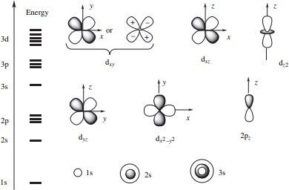

Fig. Shapes and approximate energies of some atomic orbitals

#### MOLECULAR ORBITAL THEORY

According to the molecular orbital theory put forward By Hund and Mulliken, orbital’s are divided for or the molecule as a orbitals consist of the nuclei nuclear of all the constituent atoms playing at the fix equilibrium distance these orbitals are called molecular orbital there is difference between an atomic orbital and molecular orbital in an atomic orbital movement of electron is influenced by only one positive nucleus while that it of an electron in a molecular orbital is influenced by two or more nuclear depending on the number of atoms contained in a molecule or a on the number of molecular orbital forms from the overlap of atomic orbitals thus atomic orbitals monocentric while molecular orbitals are polycentric.

#### Linear combination of atomic orbitals approximation formation of bonding and antibonding molecular orbitals.

The wave function for molecular orbitals is obtained by a method known as linear combination of atomic orbitals (LCAO) approximation. In this method the linear combination of

two atomic orbitals wave function is brought about either by adding orbits obstructing the wave functions thus if c is the wave function of the molecular orbital obtained from two atomic orbitals of two atoms A and B having ψA and ψB respectively as their function.

Then

# Molecular Orbitals of H2

The hydrogen atom is the simplest atom, and its molecule H2 is also the simplest molecule than monoatomic molecules such as He and Ne, etc. Because of their simplicity, they have been extensively studied. Many theories have been developed using them as models. For example, this diagram from g(r,theta) Plots for a Diatomic Molecule in a Lennard-Jones Fluid by Aaron Lefohn shows one of the views of the H2molecule.

### The Hydrogen Molecule

Atomic hydrogen gas is unstable, existing only at very high temperature. Diatomic hydrogen molecules, H2 are formed at ordinary temperatures and pressures. Many models and theories have been proposed to explain the chemical bond, and here are some simplified forms of these theories, some of which may have been proposed as society began to speculate what is happening. A brief review is given below, and some of these items will be further explained.

* The hydrogen atom has a valency of 1 and it tends to form a chemical bond with another atom. It forms a covalent bond with another atom of the same kind to form H−H
* When people realized that the hydrogen atom has one electron, and that He has two electrons, they thought that an atom has a tendency to share electrons to achieve a closed shell as those of inert gases. Thus, its structure should be represented by H:H the Lewis dot structure.
* The invention of quantum mechanics to describe the electron configuration of atoms led to the electron configuration of 1s1 for hydrogen. This electron tends to find a partner, and sharing an electron with another hydrogen atom seems to make it more stable.
* Atoms overlap to form a chemical bond.
* Molecular orbital (MO) theory suggested atomic orbitals which not only overlap, but are simultaneously transformed into molecular orbitals with new energies and new electron distributions.

Some facts are known about hydrogen due to some careful experimental measurements. The internuclear distance is 74 pm, and the dissociation of an H−Hbond into two atomic hydrogen atoms requires 7.2x10-19 J, (usually given as 435.9 kJ/mol).

When the 1s wave functions of the two H

Atoms are linearly combined, we get a sigma () bonding orbital, denoted as 1s in the diagram here. This approach is called linear combination of atomic orbitals (LCAO), in the MO approach. In this approach, the sum of the two 1*s* orbitals (one for each atom) is the bonding orbital. In terms of wave mechanics, the two waves constructively interact. The difference of the two orbitals forms the antibonding orbital, 1s*, due to destructive interference. It is interesting to note that the anti bonding orbital is at a higher energy than the 1s atomic orbital. The energy level can be represented below:

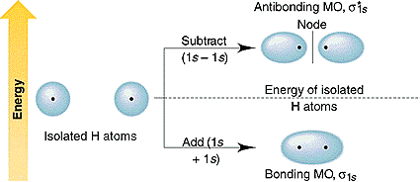

Each orbital accommodates two electrons, and the two electrons in H−H fill the 1s molecular orbital (MO). Obviously, as a result of the formation of the H2 molecule, the energy of the system is lowered and becomes more stable.

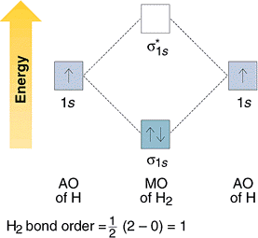

**molecular orbital energy**

A molecular orbital energy-level diagram showing the relative energies of the atomic orbitals of atoms A and B (1*s*A and 1*s*B) and the bonding (1σ) and antibonding (2σ) molecular orbitals they form.

# Molecular Orbitals of O2

The electronic configuration of oxygen (Z = 8) in the ground state is 1s22s22p4. Each oxygen atom has 8 electrons, hence, in O2 molecule there are 16 electrons. Therefore, the electronic configuration of O2 is as follows.

O2 : KK(2s )2 (*2s )2 (2pz )2 (2px )2 = (2py )2 (*2px )1 = (*2py )1 Here (1s )2 (*1s )2 part of the configuration is abbreviated as KK.

The molecular orbital energy level diagram of O2 molecule is given in Fig.

***Bond Order***

The number of bonds between a pair of atoms is called the **bond order**. Bond orders can be calculated from Lewis structures, which are the heart of the valence-bond model. Oxygen, for

Structure

example, has a bond order of two.

Bond order  (Nb Na    8  4) / 2  2.

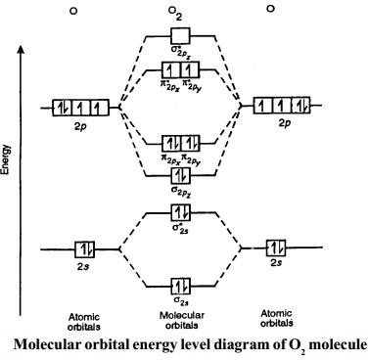

## Equations for atomic and molecular orbital.

#### Linear Combination of Atomic Orbitals (LCAO)

As per this method, the formation of orbitals is because of Linear Combination (addition or subtraction) of atomic orbitals which combine to form the molecule. Consider two atoms A and B which have atomic orbitals described by the wave functions ΨA and ΨB.

If the electron cloud of these two atoms overlaps, then we can obtain the wave function for the molecule by a linear combination of the atomic orbitals ΨA and ΨB. The below equation forms two molecular orbitals.

ΨMO = ΨA + ΨB

#### Bonding Molecular Orbitals

When the addition of wave function takes place, the type of molecular orbitals formed are Bonding Molecular Orbitals. We can represent them by ΨMO = ΨA + ΨB. They have lower energy than atomic orbitals involved.

#### Anti-Bonding Molecular Orbitals

When molecular orbital forms by the subtraction of wave function, the type of molecular orbitals formed are antibonding Molecular Orbitals. We can represent them as ΨMO = ΨA – ΨB. They have higher energy than atomic orbitals. Therefore, the combination of two atomic orbitals results in the formation of two molecular orbitals. They are the bonding molecular orbital (BMO) and the anti-bonding molecular orbital (ABMO).

#### Relative Energies of Molecular Orbitals

* **Bonding Molecular Orbitals (BMO)**

Energy of Bonding Molecular Orbitals is less than that of Anti Bonding Molecular Orbitals. This is because of the increase in the attraction of both the nuclei for both the electron (of the combining atom).

#### Anti-Bonding Molecular Orbitals (ABMO)

Energy of Anti Bonding Molecular Orbitals is higher than Bonding Molecular Orbitals.

This is because the electron tries to move away from the nuclei and are in a repulsive state.

#### Rules for Filling of Molecular Orbitals

There are certain rules while filling up molecular orbitals with electrons in order to write correct molecular configurations. They are

* **Aufbau Principle** – This principle states that those molecular orbitals which have the lowest energy are filled first.
* **Pauli’s Exclusion Principle –** According to this principle, each molecular orbital can accommodate a maximum of two electrons having opposite spins.

#### Equations for atomic and molecular orbital

1. Electrons may be assigned to definite orbital : Wave-mechanical orbitals differ fundamentally from the precisely defined orbits of the Bohr quantum theory. The electron cannot be located exactly in the orbital (uncertainty principle), and one can only calculate the probability that the electron will be present in a given volume element in the region of the nucleus.
2. An electron in a particular orbital may be assigned definite energy.
3. Only two non-identical electrons may occupy a given orbital.
4. The force involve in chemical binding are electrostatic in nature.

### Conjugated and aromatic molecules

❐ bonds in close proximity will often interact. Some of the delocalized molecular orbitals that result will be stabilized, while others will be destabilized. The individual combinations may be polarized, providing an increase in wave function amplitude on some centers at the expense of a decrease in amplitude on others. This gives rise to the possibility of more varied reactivity patterns than are observed for simple alkenes.

Aromatic molecules exhibit a wide range of reactivity patterns toward both electron rich and electron deficient species. These mainly depend on the structures and energies of the frontier -type molecular orbitals, the HOMO and LUMO. Except for non-bonded lone pairs, the  framework plays little role in the overall reactivity.

***trans*-1,3-Butadiene:**

The energies of the -molecular orbitals of conjugated molecules like butadiene, (see below) - occur in pairs, with their energies equal to (±*x*), where  and  are constants. For each bonding orbital of and energy -*x* there is a corresponding antibonding orbital of energy +*x*. The -molecular orbitals are extended over the whole molecule.

For butadiene, the  manifold contains four electrons, leading to an electronic configuration of 1222.

For the energy diagram and pictorial view of the -molecular orbitals - please see below:

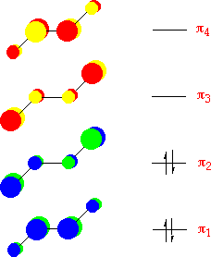

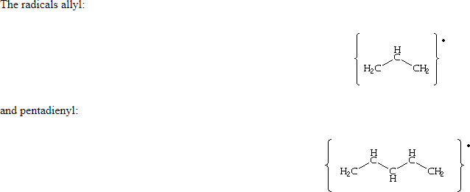

have the same arrangement of -orbitals, (ie. the occur in pairs of energy ±*x*), but because there is an odd number of carbon atoms in the conjugate chain, there must be a non-bonding orbital with energy *x=*0. Also, because of the pairing properties of the -molecular orbitals of conjugated chains, there will be a node at every alternate carbon atom in the non-bonding orbital. This is important for the unpaired electron of allyl, which will occupy this non-bonding orbital. If an electron is added to the allyl radical to form the anion, the negative charge will appear at the terminal carbon atoms. If the unpaired electron is removed forming the cation, the resulting positive charge is also spread over the termial carbon atoms. There are three -molecular orbitals for allyl, the 1 is bonding, the 2 orbital is non- bonding and the 3 is anti-bonding. In the neutral allyl species - there are a total of seventeen valence electrons - of which three fill the -orbital manifold. A pictorial representation of the energy diagram for the neutral, cationic and anionic allyl species are shown below - (*orbitals are shown only for the cationic species*):

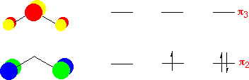

In the pentadienyl anion, the negative charge is centred on the carbon atoms in the 1,3 and 5 position - similarly with the positive charge for the cation.

These ions are represented in resonance theory as two or three canonical forms:

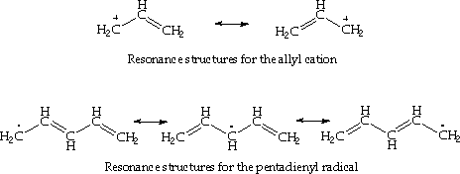

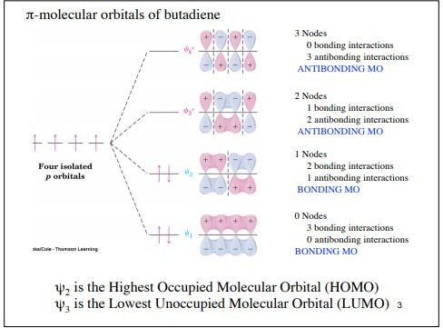

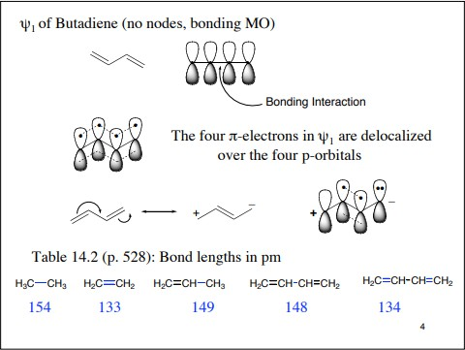

#### Pi-molecular orbitals of benzene

According to this theory, all the C-atoms in benzene are sp2-hybridized. Two sp2-hybrid orbitals of each C-atom overlap with two sp2-hybrid orbital of two other C-atoms to form sigma bonds. In this way there are six sigma bonds are formed between six C-atoms which are 120o apart. Remaining six sp2-orbital of six C-atoms overlap with 1s orbital of six H-atoms individually to form six sigma bonds. Since sigma bond results from the overlap of above said planar orbital, all H and C atoms are in the same plane and their generate a hexagonal ring of C-atoms.

Each C-atom in benzene also has an unhybrid 2pz-orbital containing one electron. These 2pz-orbital are perpendicular to the plane of sigma bonds. Pz orbital in benzene

These 2pz-orbitals by lateral overlapping form three alternate pi-bonds in benzene ring.

There are two possibilities of pi-bond formation in benzene.

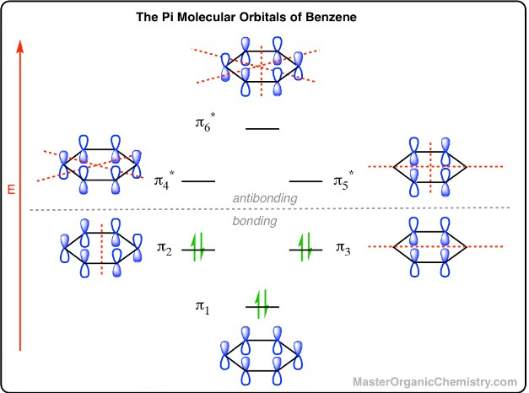

Pi-molecular orbitals of aromaticity

#### BOND LENGTH ANALYSIS IN BENZENE

C-C length in alkane = 1.54oA C=C length in alkene = 1.34oA But in benzene,

C-C length = 1.397oA C=C length = 1.397oA

This shows that in benzene single and double bonds have quite extraordinary character as they do not resemble to alkane and alkene in bond lengths. That is why benzene shows a behavior of saturated as well as an unsaturated hydrocarbon simultaneously. The orbital structure of benzene: All the carbon atoms in benzene are sp2 hybridised. The three sp2 hybrid orbitals are lying in one plane and oriented at an angle of 120°. The fourth unhybridized p- orbital having two lobes is lying perpendicular to the plane of the hybrid orbital. Two out of the three sp2 hybrid orbitals of each carbon atom overlap axially with sp2 hybrid orbitals of the neighbouring carbon atoms on either side to form carbon-carbon σ bonds. The third hybrid orbital of each carbon atom overlaps axially with the half filled 1s- orbital of the hydrogen atom to form carbon-hydrogen sigma bonds. Thus there is six sigma C-C bonds and six sigma

C-H bonds. There is still one unhybridized 2pz orbital on each carbon atom. This orbital consists of two lobes, one lying above and the other below the plane of the ring.

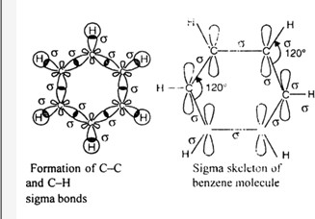

The unhybridized 2pz orbital on each carbon atom can overlap sidewise with the 2pzorbital of the two adjacent carbon atoms in two different ways as shown below giving rise to two sets of straight pi-bonds. Since 2pz orbital on any carbon atom can overlap sideways with the 2pz orbital on adjacent carbon atom on either side equally well, a continuous straight pi-molecular 3 orbitals will result which embraces all the six p-electrons as shown:

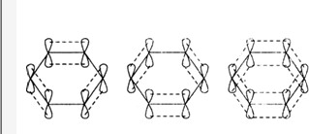

The net result is that there are two continuous rings-like electron clouds, one above and the other below the plane of atoms as shown. This delocalisation of π-electrons imparts unique stability to the benzene molecule.

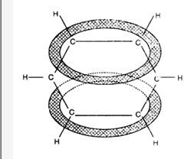

In benzene molecule all  and  are of 120° each and each C-C bond length is 139 pm.

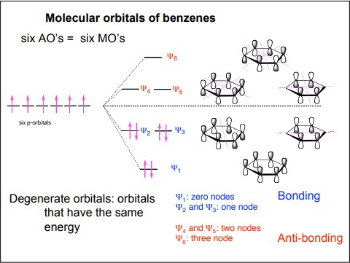

## Aromatic

**Cyclic Conjugated:** “alternating single and double bonds” Flat: maximum overlap between conjugated π-bonds Must contain 4n+2 π-electrons, where n is an integer (Hückel’s rule)

**Anti-aromatic:** cyclic, conjugated, flat molecules that contain 4n π-electrons (where n is an integer). Destabilized (highly reactive) relative to the corresponding open-chain conjugated system

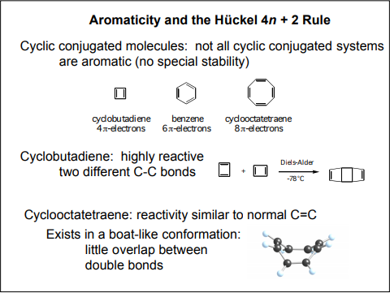

Crystal Field Theory

Crystal field theory (CFT) describes the breaking of orbital degeneracy in [transition metal](https://chem.libretexts.org/Bookshelves/Ancillary_Materials/Demos%2C_Techniques%2C_and_Experiments/Lecture_Demonstrations/Additional_Demos/Transition_Metal_Complexes) [complexes](https://chem.libretexts.org/Bookshelves/Ancillary_Materials/Demos%2C_Techniques%2C_and_Experiments/Lecture_Demonstrations/Additional_Demos/Transition_Metal_Complexes) due to the presence of [ligands](https://chem.libretexts.org/Bookshelves/Inorganic_Chemistry/Modules_and_Websites_(Inorganic_Chemistry)/Coordination_Chemistry/Structure_and_Nomenclature_of_Coordination_Compounds/Ligands). CFT qualitatively describes the strength of the metal-ligand bonds. Based on the strength of the metal-ligand bonds, the energy of the system is altered. This may lead to a change in [magnetic properties](https://chem.libretexts.org/Bookshelves/Physical_and_Theoretical_Chemistry_Textbook_Maps/Supplemental_Modules_(Physical_and_Theoretical_Chemistry)/Physical_Properties_of_Matter/Atomic_and_Molecular_Properties/Magnetic_Properties) as well as [color](https://chem.libretexts.org/Bookshelves/Inorganic_Chemistry/Modules_and_Websites_(Inorganic_Chemistry)/Crystal_Field_Theory/Colors_of_Coordination_Complexes). This theory was developed by Hans Bethe and John Hasbrouck Van Vleck.